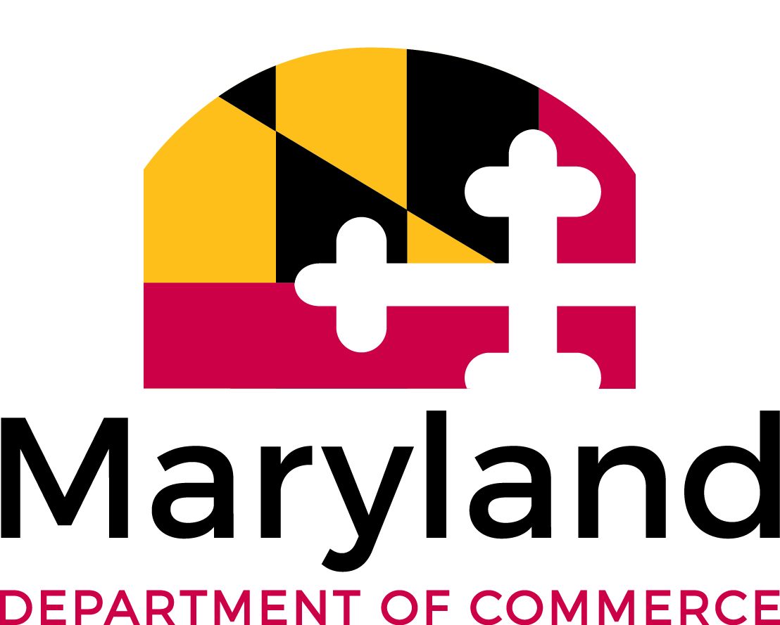
EB-5 VISA TARGETED EMPLOYMENT AREA (TEA) DESIGNATION REQUEST

Part 1: Requester
Name: | Click here to enter text.
Address: | Click here to enter text.
City: | Click here to enter text.
State: | Click here to enter text.
Zip Code: | Click here to enter text.
Phone: | Click here to enter text.
Email: | Click here to enter text.
Company: | Click here to enter text (if applicable).
Title: | Click here to enter text (if applicable).
Website: | Click here to enter text (if applicable).

Part 2: Entity Information
If the business is currently operating, provide the legal name as registered with the Maryland Department of Business and Economic Development.
Legal Name: | Click here to enter text (if applicable).
If you intend to qualify by rural criteria, provide the Maryland county identification.
County Identification: | Click here to enter text.
If you intend to qualify by unemployment criteria, provide the Maryland county identification and Census tract codes:
County Identification: | Click here to enter text.
Census Tract(s): | Click here to enter text.

Part 3: Project Information
Industry/type of jobs: | Click here to enter text.
Project Description: | Click here to enter text.
Regional Center Affiliation: | Click here to enter text (if applicable).

Part 4: EB-5 Visa Applicant/Potential Benefactor Information
Nationality: | Click here to enter text.
If the Applicant/Potential Benefactor is different than the Requester, complete the following:
Name: | Click here to enter text.
Address: | Click here to enter text.
City: | Click here to enter text.
State: | Click here to enter text.
Zip Code: | Click here to enter text.
Phone: | Click here to enter text.
Email: | Click here to enter text.

The Maryland Department of Commerce, in accordance with federal guidelines, has been designated by the Governor of Maryland to review and confirm TEA requests.
To qualify as a TEA, a location must be within a rural area or have an unemployment rate that equals or exceeds 150% of the corresponding national unemployment rate. Commerce can provide a spreadsheet showing where most of these areas are located in Maryland. Rural area is defined as an area not within a metropolitan statistical area as defined by the Office of Management and Budget.
Questions and completed Confirmation Requests should be directed to Paul Beatty (paul.beatty@maryland.gov), Director of Strategic Initiatives with the Office of International Investment and Trade. Please allow 30 days for the completed designation letter to be completed.

