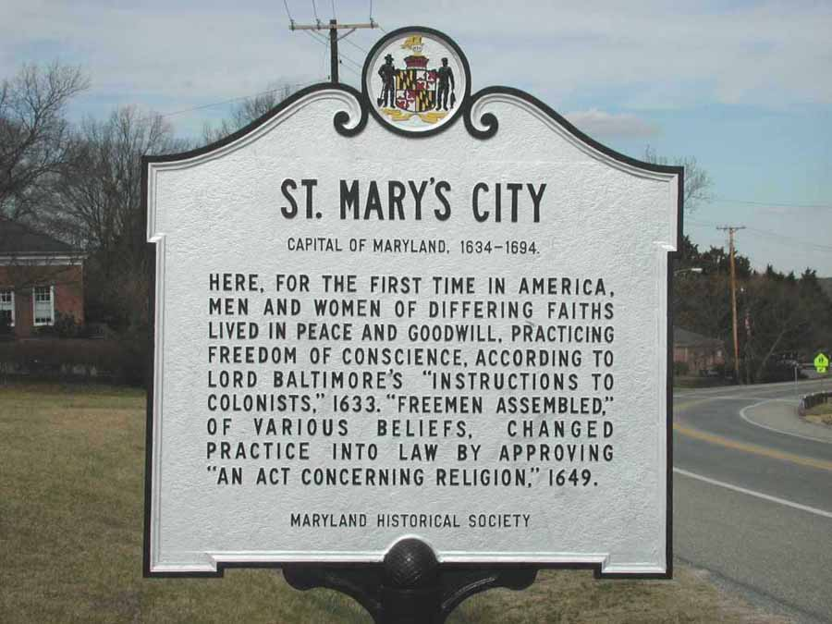
Historic St. Mary’s City
Fort to 400 Commission Report
August 11, 2022



PREFACE
This document meets the administrative duty of the commission to provide a report of the Commission’s plan for the Commemoration of the 400th Anniversary of the Founding of Maryland as set forth by House Bill 1364, the act concerning History St. Mary’s City Fort to 400 Commission.
House Bill 1364 outlined the duties of the commission and that it will be staffed by the Maryland Office of Tourism with assistance from the Maryland Historical Trust and the Maryland State Archives. The Commission is deemed to provide leadership for and coordination of economic development opportunities in and around St. Mary’s City to promote the region for future generations.
The 19-member Commission Consists of the following Members:
- Five Governor appointed members
- Two Senate President appointed members
- Two House Speaker appointed members
and representation from the following agencies/organizations:
- Historic St. Mary’s City Commission
- Maryland Department of Budget and Management
- Maryland Department of Natural Resources
- Maryland Department of Commerce
- Maryland Department of Planning
- Maryland Department of Transportation
- Maryland Commission of Indian Affairs
- Maryland Commission of African American History and Culture
- Maryland Rediscovery 400 Initiative
As stated in HB 1364, the Governor appointed Mr. Brian Norris, Owner, Cherry Cove Hospitality Management as the Chair of the Historic St. Mary’s Fort to 400 Commission.
As stated in the HB 1364, the committee developed the following action plan:

ACTION | EXECUTION
Establish communication portal for 400 Commission | Brian Norris has taken this responsibility.
Create 501c- Will take time to create | Blackie Wills has taken this responsibility.
Commission is planning on meeting as needed and will be breaking into smaller committees as outlined in the legislation. | The next meeting will be held at St. Mary’s College – in October.  Goal of next meeting: Confirm event timeline with desirables/ vision/mission.

Sen. Bailey stated that legislators are also interested and suggested that perhaps Southern Maryland be included in the Legislator’s Freshman Tour.
Contact other organizations to complete Commission composition. | Liz Fitzsimmons to send notice to all Cabinet and Office executives for their representative to the Commission.
Develop talking points “elevator pitch” by November 2022. Pitch is needed to bring others on board. The goal of the Commission needs to be articulated properly to engage supporters and funders. Inclusivity is very important to accomplishing the goal and should be included in formulating mission, vision, and specific goals. | SWOT analysis suggested by Chair Norris to help develop pitch.
Survey every county in Maryland to ask, “what outcome they would like to see out of the 400 celebration?” | OTD will develop a survey and send it to the counties via the tourism offices by October 2022 for discussion at December 2022 meeting.
Determine best practices for historic celebrations. | Liz Fitzsimmons will reach out to former Maryland War of 1812 Bicentennial Commission Chair Bill Pencek. Heather Ersts, who worked at the Maryland Office of Tourism and with the War of 1812 Commission has agreed to share the best practices of the War of 1812 Commission.
Determine a plan for spending the $125,000 in capital funding Senator Bailey informed the Commission exists. | The Commission can use the funds for planning and operational expenses by December 2022.
Determine staffing plan and when does it take effect. | Commission to explore hiring an Executive Director perhaps in year 2.  Form a smaller Executive Committee within the group to make some decisions by December 2022.
400 Commission status report due November 1, 2022 | Articulate mission, mission vision, elevator pitch, goals, funding requests.

The committee was appointed by Governor Larry Hogan, and Brian Norris, Owner, Cherry Cove Hospitality Management has been named Chair of the Fort to 400 Commission.
The Chair’s duties include and are not limited to:
- Sponsor Recruitment and Development
- Stewardship and Visitor Experiences
- Education and Curriculum
- Program and Events
- Transportation and Capital Infrastructure
- Communication and Marketing
- Operations and Management
Duties of the Commission include and are not limited to:
- Coordinate the planning and implementation of the activities and events
- Promote the identification, documentation and preservation of historical and cultural resources related to the founding of Maryland
- Assist in promoting, improving and developing existing educational and interpretive institutions, sites and museums related to the founding
- Develop a model social studies curriculum on the founding
- Promote nationally and internationally the commemoration of the founding
- Ensure activities, events, and products that provide lasting value and benefit
- Secure support and financial resources to implement the activities and events of the commission
- Provide leadership for and coordinate economic opportunities in and around St. Mary’s
- Perform other actions necessary to carry out the purposes of the commission
Historic St. Mary’s City Fort to 400 Commission Members Include: (As of July 2022)
  - Brian Norris, President and Chief Executive Officer,
The Cherry Cove Group
  - Liz Fitzsimmons, Managing Director, Maryland Office of
Tourism and Film
  - Senator Jack Bailey, Maryland State Senate
  - Senator Arthur Ellis, Maryland State Senate
  - Delegate Brian Crosby, Maryland House of Delegates
  - Delegate Marc Korman, Maryland House of Delegates
  - Julian (Blackie) Wills, President and Chief Operating Officer,
The Wills Group
- Michael Alderson, Jr, Project Manager, St. Mary’s County
  - Marianne Harms, Philanthropist, Calvert County
  - Dr. Tuajuanda Jordan, PhD, President, St. Mary’s College of Maryland
  - Dr. Regina Faden, PhD, Executive Director, Historic St. Mary's City
  - Dr. Julie Schablitsky, PhD, Archeologist, Adjunct Professor, and Chief of the Cultural Resources Division at the Maryland Department of Transportation
  - Lucille Walker, Executive Director, Destination Southern Maryland
  - Barbara Sopato, Executive Director, Visit St. Mary’s
  - Hilary Dailey, Tourism Program Specialist, Calvert County Department of Economic Development
  - Ashley Chenault, Chief of Tourism, Explore Charles County
Ex officio: David R. Brinkley, Secretary of Budget & Management; R. Michael Gill, Secretary of Commerce; Jeannie Haddaway-Riccio, Secretary of Natural Resources; Robert S. McCord, Esq., Secretary of Planning; James F. Ports, Jr., Secretary of Transportation.
Staff: Office of Tourism & Film
Division of Marketing, Tourism & the Arts
Department of Commerce
World Trade Center Baltimore, 14th floor, 401 East Pratt St., Baltimore, MD 21202
(410) 767-6331
Contacts:
Liz Fitzsimmons, Managing Director, Maryland Department of Commerce,
Office of Tourism & Film
elizabeth.fitzsimmons@maryland.gov
Julia Bouie, Executive Assistant, Maryland Department of Commerce,
Office of Tourism & Film
Julia.bouie2@maryland.gov
Additional assistance will be provided by the Maryland Historical Trust and the Maryland State Archives.

SUPPORTING DOCUMENTATION:
Press Release
Governor Hogan Announces Appointments to the Historic St. Mary’s City Fort to 400 Commission
ANNAPOLIS, MD—Governor Larry Hogan today announced that he has appointed six members to the Historic St. Mary’s City Fort to 400 Commission, which is responsible for planning and conducting observances in 2034 commemorating the 400th anniversary of Maryland’s founding. Earlier this year, Governor Hogan enacted House Bill 1364, establishing the commission.
The governor has designated Brian K. Norris as chair of the commission and remaining members will include:
- Michael R. Alderson Jr,
- Marianne Harms
- Barbara Ives
- Tuajuanda C. Jordan, Ph.D.
- Julian Blacklock Wills, III
These appointments took effect on October 1, 2021.
“As one of the earliest settlements in the New World and Maryland’s first city, St. Mary’s City holds a special place in the history of our state and the nation,” said Governor Hogan. “I am proud to appoint these Marylanders who will work diligently over the next decade to celebrate and commemorate the founding of this historic landmark.”
Assisted by the Maryland Historical Trust and the State Archives, the Office of Tourism and Film provides staff to the Commission. Nineteen members constitute the Commission. The Governor appoints five members, and the Senate President and House Speaker each appoint two members. One member each represents the Commission on African American History and Culture; the Commission on Indian Affairs; the Historic St. Mary’s City Commission; the Maryland Rediscovery 400 Initiative; and St. Mary’s College of Maryland. Five members serve ex officio (Code State Government Article, sec. 9-3301 through 9-3307). Authorization for the Commission ends September 30, 2035.

______________________________________

VIDEO AND PHOTO RELEASE: Governor Hogan Commemorates Maryland Day in Historic St. Mary’s City
ANNAPOLIS, MD—Governor Larry Hogan today joined federal, state, and local elected officials for the Maryland Day Weekend celebration in Historic St. Mary’s City, which was the site of Maryland’s first capital. During the event, the governor was presented with the Cross Bottony award—the museum’s highest honor—for his many years of support for Historic St. Mary’s City.
“The recognition of Maryland Day began in 1903 as a simple observance by school systems, but over the many years it has grown into something much bigger—a wonderful celebration of our state’s history, our culture, achievements, and traditions,” said Governor Hogan. “My hope is that more Marylanders and visitors from across the country and around the world will come visit here to learn about and to experience all that St. Mary’s City has to offer, especially in the years ahead as we prepare to commemorate the 400th anniversary of Maryland’s founding.”
On March 25, 1634, the Ark and the Dove, carrying 150 European settlers, landed on St. Clements Island. In 1916, the General Assembly passed legislation officially making Maryland Day a state holiday.
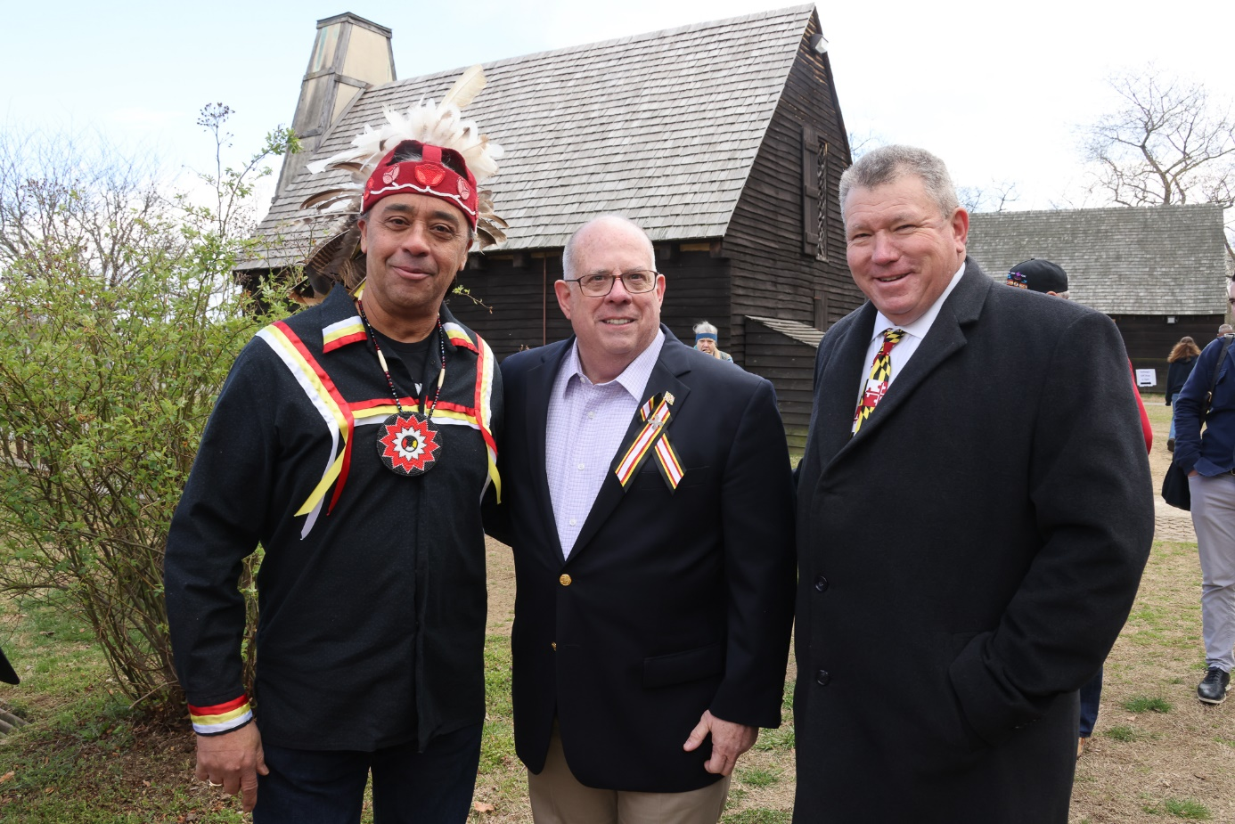
In September, Governor Hogan announced the appointment of six members to the Historic St. Mary’s City Fort to 400 Commission, which is responsible for planning and conducting observances in 2034 commemorating the 400th anniversary of Maryland’s founding. The governor previously enacted House Bill 1364, establishing the commission.
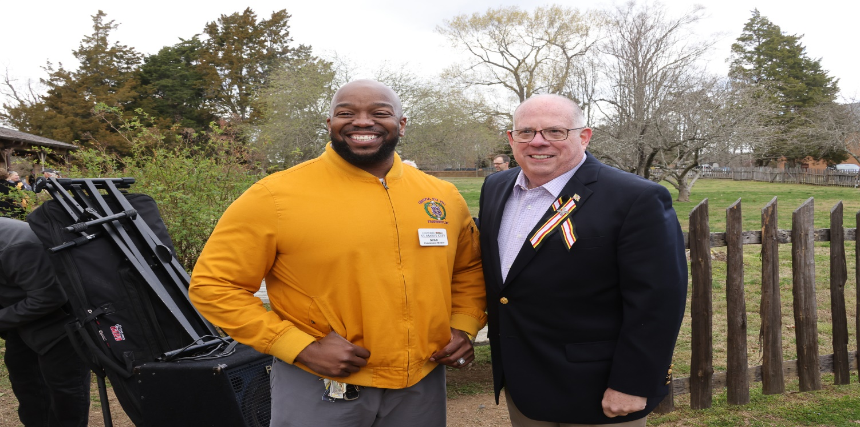
_________________________________________________________________________________
Last spring, Governor Hogan visited Historic St. Mary’s City to see recently discovered artifacts at the site of the St. Mary’s Fort, built by the first wave of 150 European settlers to land in Maryland in 1634. The discovery of the original St. Mary’s Fort, announced in late March, was the culmination of a search that dated back nearly 90 years.

LEGISLATION

LAWRENCE J. HOGAN, JR., Governor Ch. 688 – 1 – Chapter 688 (Senate Bill 946) AN ACT concerning Historic St. Mary’s City Fort to 400 Commission FOR the purpose of establishing the Historic St. Mary’s City Fort to 400 Commission for a certain purpose; providing for the membership, chair, and staffing of the Commission; prohibiting a member of the Commission from receiving certain compensation, but authorizing the reimbursement of certain expenses; requiring the Governor to fill a certain vacancy on the Commission under certain circumstances; providing for the duties of the Commission; requiring the Commission to establish certain advisory committees; requiring the Commission to meet at certain times; requiring the Commission to submit certain reports to the Governor and the General Assembly at certain times; defining a certain term; providing for the termination of this Act; and generally relating to the Historic St. Mary’s City Fort to 400 Commission. BY adding to Article – State Government Section 9–3301 through 9–3307 to be under the new subtitle “Subtitle 33. Historic St. Mary’s City Fort to 400 Commission” Annotated Code of Maryland (2014 Replacement Volume and 2020 Supplement) Preamble WHEREAS, In 1634, the settlers who founded Maryland landed at St. Clements Island aboard the Ark and the Dove, before establishing the colony at St. Mary’s City; and WHEREAS, It is appropriate for the State of Maryland to plan and conduct observances marking the 400th anniversary of the founding of Maryland in 2034; and WHEREAS, As Maryland’s first settlement and first capital, Historic St. Mary’s City will play an important role in leading these observances; and WHEREAS, It is in the interest of Marylanders to provide for appropriate activities to commemorate and maximize the understanding of residents and visitors about the founding of Maryland and its meaning to Marylanders, particularly of Maryland’s leadership in establishing the principle of religious toleration; and WHEREAS, The General Assembly desires that these events be carried out in a historically accurate, inclusive, cohesive, and dignified manner and desires to create a coordinating mechanism to ensure efficiency and to advise the Governor and the General Assembly of how best to observe this anniversary across our State; now, therefore, Ch. 688 2021 LAWS OF MARYLAND – 2 – SECTION 1. BE IT ENACTED BY THE GENERAL ASSEMBLY OF MARYLAND, That the Laws of Maryland read as follows: Article – State Government SUBTITLE 33. HISTORIC ST. MARY’S CITY FORT TO 400 COMMISSION. 9–3301. IN THIS SUBTITLE, “COMMISSION” MEANS THE HISTORIC ST. MARY’S CITY FORT TO 400 COMMISSION. 9–3302. (A) THERE IS A HISTORIC ST. MARY’S CITY FORT TO 400 COMMISSION. (B) THE PURPOSE OF THE COMMISSION IS TO PLAN, PRODUCE, AND FACILITATE MATERIALS, EVENTS, AND ACTIVITIES TO COMMEMORATE THE 400TH ANNIVERSARY OF THE FOUNDING OF MARYLAND. 9–3303. (A) THE COMMISSION CONSISTS OF THE FOLLOWING MEMBERS: (1) THE PRESIDENT OF THE SENATE; (2) THE SPEAKER OF THE HOUSE; (3) (1) ONE MEMBER TWO MEMBERS OF THE SENATE OF MARYLAND, APPOINTED BY THE PRESIDENT OF THE SENATE; (4) (2) ONE MEMBER TWO MEMBERS OF THE HOUSE OF DELEGATES, APPOINTED BY THE SPEAKER OF THE HOUSE; (5) (3) THE SECRETARY OF BUDGET AND MANAGEMENT OR THE SECRETARY’S DESIGNEE; (6) (4) THE SECRETARY OF COMMERCE OR THE SECRETARY’S DESIGNEE; (7) (5) THE SECRETARY OF NATURAL RESOURCES OR THE SECRETARY’S DESIGNEE; LAWRENCE J. HOGAN, JR., Governor Ch. 688 – 3 – (8) (6) THE SECRETARY OF PLANNING OR THE SECRETARY’S DESIGNEE; (9) (7) THE SECRETARY OF TRANSPORTATION OR THE SECRETARY’S DESIGNEE; (10) (8) ONE REPRESENTATIVE OF THE MARYLAND COMMISSION ON INDIAN AFFAIRS; (11) (9) ONE REPRESENTATIVE OF THE MARYLAND COMMISSION ON AFRICAN AMERICAN HISTORY AND CULTURE; (12) (10) ONE REPRESENTATIVE OF THE HISTORIC ST. MARY’S CITY COMMISSION; (13) ONE REPRESENTATIVE OF ST. MARY’S COLLEGE OF MARYLAND; (14) (11) ONE REPRESENTATIVE OF THE MARYLAND REDISCOVERY 400 INITIATIVE; AND (15) (12) FIVE MEMBERS WITH RELEVANT INTEREST OR EXPERTISE, APPOINTED BY THE GOVERNOR. (B) TO THE EXTENT PRACTICABLE, THE MEMBERSHIP OF THE COMMISSION AND ANY ADVISORY COMMITTEES ESTABLISHED IN ACCORDANCE WITH § 9–3305 OF THIS SUBTITLE SHALL BE REPRESENTATIVE OF THE DIVERSE COMMUNITIES AND REGIONS WITHIN THE STATE. (C) THE GOVERNOR SHALL DESIGNATE THE CHAIR OF THE COMMISSION. (D) THE DIVISION OF TOURISM, FILM, AND THE ARTS SHALL PROVIDE STAFF FOR THE COMMISSION, ASSISTED BY THE MARYLAND HISTORICAL TRUST AND THE MARYLAND STATE ARCHIVES. (E) A MEMBER OF THE COMMISSION: (1) MAY NOT RECEIVE COMPENSATION AS A MEMBER OF THE COMMISSION; BUT (2) IS ENTITLED TO REIMBURSEMENT FOR EXPENSES UNDER THE STANDARD STATE TRAVEL REGULATIONS, AS PROVIDED IN THE STATE BUDGET. Ch. 688 2021 LAWS OF MARYLAND – 4 – (F) A VACANCY ON THE COMMISSION SHALL BE FILLED BY THE GOVERNOR. 9–3304. THE COMMISSION SHALL: (1) COORDINATE THE PLANNING AND IMPLEMENTATION OF ACTIVITIES AND EVENTS TO COMMEMORATE THE 400TH ANNIVERSARY OF THE FOUNDING OF MARYLAND; (2) PROMOTE THE IDENTIFICATION, DOCUMENTATION, AND PRESERVATION OF HISTORICAL AND CULTURAL RESOURCES RELATED TO THE FOUNDING OF MARYLAND; (3) ASSIST IN PROTECTING, IMPROVING, AND DEVELOPING EXISTING EDUCATIONAL AND INTERPRETIVE INSTITUTIONS, SITES, AND MUSEUMS IN PROMOTING THE 400TH ANNIVERSARY OF THE FOUNDING OF MARYLAND; (4) ENSURE DEVELOPMENT OF A MODEL SOCIAL STUDIES CURRICULUM ON THE FOUNDING OF MARYLAND; (5) PROMOTE NATIONALLY AND INTERNATIONALLY THE COMMEMORATION OF THE 400TH ANNIVERSARY OF THE FOUNDING OF MARYLAND; (6) ENSURE THAT COMMEMORATIVE ACTIVITIES, EVENTS, AND PRODUCTS PROVIDE LASTING VALUE AND PUBLIC BENEFITS BEYOND THE CELEBRATION OF THE 400TH ANNIVERSARY OF THE FOUNDING OF MARYLAND; (7) SECURE SUPPORT AND FINANCIAL RESOURCES TO IMPLEMENT EVENTS AND ACTIVITIES PLANNED AND ASSISTED BY THE COMMISSION, INCLUDING THE FORMATION OF AN APPROPRIATE LEGAL ENTITY; (8) PROVIDE LEADERSHIP FOR AND COORDINATE ECONOMIC DEVELOPMENT OPPORTUNITIES IN AND AROUND ST. MARY’S CITY TO PROMOTE THE REGION FOR FUTURE GENERATIONS; AND (9) PERFORM OTHER ACTIONS NECESSARY TO CARRY OUT THE PURPOSES OF THE COMMISSION. 9–3305. (A) THE CHAIR OF THE COMMISSION SHALL ESTABLISH ADVISORY COMMITTEES RELATED TO: LAWRENCE J. HOGAN, JR., Governor Ch. 688 – 5 – (1) DEVELOPMENT AND SPONSOR RELATIONS; (2) RESOURCE STEWARDSHIP AND VISITOR EXPERIENCE; (3) EDUCATION AND CURRICULUM; (4) PROGRAMS AND EVENTS; (5) TRANSPORTATION AND CAPITAL INFRASTRUCTURE; (6) COMMUNICATIONS AND MARKETING; (7) OPERATIONS AND MANAGEMENT; AND (8) ANY OTHER ASPECT OF THE COMMEMORATION OF THE 400TH ANNIVERSARY OF THE FOUNDING OF MARYLAND THAT THE CHAIR CONSIDERS NECESSARY. (B) (1) THE CHAIR OF THE COMMISSION SHALL APPOINT ADVISORY COMMITTEE MEMBERS WHO BROADLY REPRESENT PUBLIC AND PRIVATE INTERESTS. (2) ADVISORY COMMITTEE MEMBERS SERVE AT THE PLEASURE OF THE CHAIR OF THE COMMISSION. 9–3306. (A) THE COMMISSION SHALL MEET AT LEAST TWICE EACH YEAR AT TIMES AND PLACES TO BE DETERMINED BY THE CHAIR. (B) THE COMMISSION: (1) SHALL ADOPT PROCEDURES FOR THE TRANSACTION OF BUSINESS; AND (2) MAY ESTABLISH A NONPROFIT ORGANIZATION TO RECEIVE FUNDS FOR THE COMMISSION. 9–3307. (A) ON OR BEFORE SEPTEMBER 1, 2022, THE COMMISSION SHALL SUBMIT TO THE GOVERNOR AND, IN ACCORDANCE WITH § 2–1257 OF THE STATE GOVERNMENT ARTICLE, THE GENERAL ASSEMBLY A REPORT CONTAINING THE COMMISSION’S PLAN OF ACTION FOR THE COMMEMORATION OF THE 400TH Ch. 688 2021 LAWS OF MARYLAND – 6 – ANNIVERSARY OF THE FOUNDING OF MARYLAND. (B) ON OR BEFORE NOVEMBER 1, 2022, AND EACH NOVEMBER 1 THEREAFTER, THE COMMISSION SHALL SUBMIT TO THE GOVERNOR AND, IN ACCORDANCE WITH § 2–1257 OF THE STATE GOVERNMENT ARTICLE, THE GENERAL ASSEMBLY A REPORT THAT INCLUDES: (1) AN UPDATE ON THE PLAN OF ACTION SUBMITTED IN ACCORDANCE WITH SUBSECTION (A) OF THIS SECTION; (2) IMPLEMENTATION TIMETABLES AND BENCHMARKS; AND (3) RECOMMENDATIONS FOR LEGISLATIVE, ADMINISTRATIVE, AND OTHER ACTIONS THE COMMISSION DEEMS NECESSARY TO FURTHER ITS MISSION. SECTION 2. AND BE IT FURTHER ENACTED, That this Act shall take effect October 1, 2021. It shall remain effective for a period of 14 years and, at the end of September 30, 2035, this Act, with no further action required by the General Assembly, shall be abrogated and of no further force and effect. Enacted under Article II, § 17(c) of the Maryland Constitution, May 30, 2021.
COMMISSION MEETINGS
The initial meeting of the Commission was held virtually on Thursday March 10, 2022. The second meeting which was held in person on April 20, 2022, at the Inn at Leonardtown with the attendees listed below.
- Brian Norris
- Liz Fitzsimmons
- Sen. Jack Bailey
- Sen. Arthur Ellis
- Del. Brian Crosby
- Julian (Blackie) Wills
- Dr. Julie Schablitsky
- Lucille Walker
- Marianne Harms
- Tuajuanda Jordan
- Del. Marc Korman
- Dr. Regina Faden
- Barbara Sopato, Visit St. Mary’s
- Hilary Dailey, Calvert County Department of Economic Development
- Maggie Boyden, Tour Charles County Government (attending for Ashley Chenault)
- Brandon Rosario (Intern)
- Julia Bouie

Commission Planning: Establish advisory committees as outlined in Historic St. Mary’s City Fort to 400 Commission CH 687, Acts of 2021 - Liz Fitzsimmons

ACTION PLAN
The Commission developed a plan of action to further goals and take concrete steps toward completion of goals of the Commission. The plan follows on the next page.
ACTION | EXECUTION
Establish communication portal for 400 Commission | Brian Norris has taken this responsibility.
Create 501c- Will take time to create. Do we use another established organization (i.e., Historic St. Mary’s Trust?) for 400 Commission funds to be deposited into? | Blackie Wills has taken this responsibility.
Determine how often the Commission should Commission meet? Twice? | Dr. Faden and Dr. Jordan will host the next meeting with a tour perhaps in late June or after the 4th of July.  Goal of next meeting: Confirm event timeline with desirables/ vision/mission.  Sen. Bailey stated that legislators are also interested and suggested that perhaps Southern Maryland be included in the Legislator’s Freshman Tour.
Contact other organizations to complete Commission composition. | Liz Fitzsimmons to send notice to all Cabinet and Office executives for their representative to the Commission.)
Develop talking points “elevator pitch” by November report. Pitch is needed to bring others on board. The goal of the Commission needs to be articulated properly to engage supporters and funders. Inclusivity is very important to accomplishing the goal and should be included in formulating mission, vision and specific goals. | SWOT analysis suggested by Chair Norris to help develop pitch.
Survey every county in Maryland to ask, “what outcome they would like to see out of the 400 celebration?” | OTD will develop a survey and send it to the counties via the tourism offices.
Schedule a call with the Maryland War of 1812 Bicentennial Commission to learn about their experiences completing goals and if they could share any research, best practices, lessons learned. | Liz Fitzsimmons will reach out to former Maryland War of 1812 Bicentennial Commission chair Bill Pencek.  Heather Ersts, who worked in the Maryland Office of Tourism and with the War of 1812 Commission has agreed to share the best practices of the War of 1812 Commission.
Determine a plan for spending the $125,000 in capital funding Senator Bailey informed the Commission exists. | The Commission can use the funds for planning and operational expenses. Lucille Walker has the 1812 funding chart and will send it to Liz Fitzsimmons.
Hire an Executive Director for Commission or third party strategic planner? Or do we plan ourselves? | Commission to explore hiring an Executive Director perhaps in year 2?  Form a smaller Executive Committee within the group to make some decisions?
400 Commission status report due November 1, 2022 | The report should include the ask from Sen. Jack Bailey, for having the commission and others to work in a bi-partisan manner. Include advisory committees formed (Commission members should act as advisory persons).  Articulate mission, mission vision, elevator pitch, goals, funding requests.

